ACAPS Annotation Practice

Author | - Look for a caption or authors signature.  - Look for capital letters (names are proper nouns)  - Label – Author by circling and writing AUTHOR
Context | - Look for the date  - Identify and note events that were occurring during this time period –note these events next to the date  - Label what figures, symbols and words are representing
Audience | - Look for clues;  - What language is it written in?  - How are the people/ideas shown?  - What is it about?  - Think - who might care about this? Age, nationality, interests etc.  - Suggest an audience – note it down
Purpose | - What is the context?  - What is the main idea (message)  - Identify if the the author wants you to  - Do something?  - Think something?  - Feel something?  - Note the purpose
Significance | - Why is the message of this source important?  - What interesting perspective does it suggest?  - Note the significance
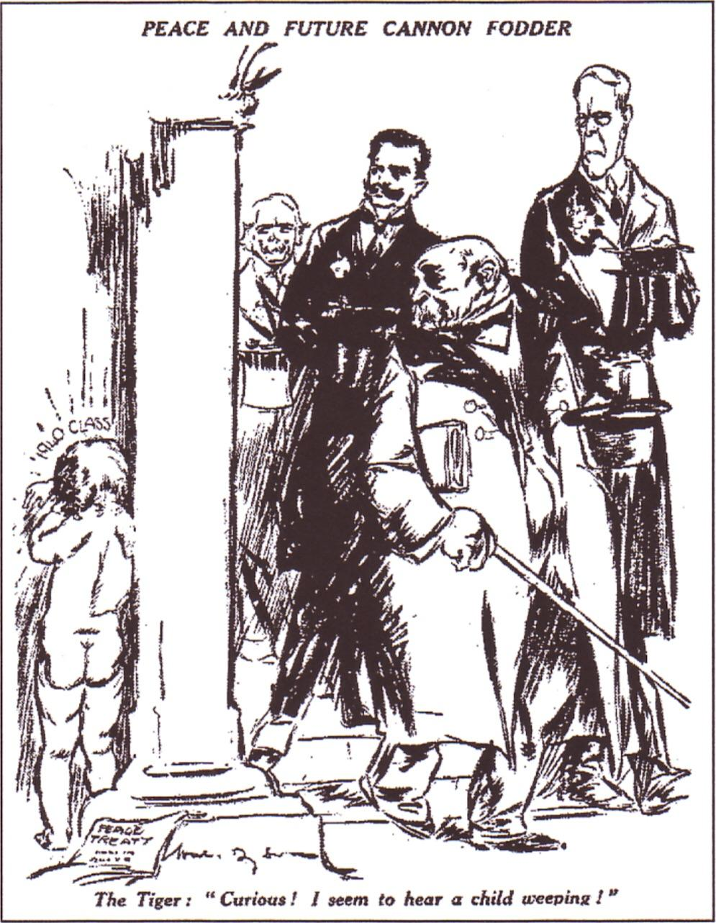

SOURCE 1 Will Dyson, 1919
Author | - Look for a caption or authors signature.  - Look for capital letters (names are proper nouns)  - Label – Author by circling and writing AUTHOR
Context | - Look for the date  - Identify and note events that were occurring during this time period –note these events next to the date  - Label what figures, symbols and words are representing
Audience | - Look for clues;  - What language is it written in?  - How are the people/ideas shown?  - What is it about?  - Think - who might care about this? Age, nationality, interests etc.  - Suggest an audience – note it down
Purpose | - What is the context?  - What is the main idea (message)  - Identify if the the author wants you to  - Do something?  - Think something?  - Feel something?  - Note the purpose
Significance | - Why is the message of this source important?  - What interesting perspective does it suggest?  - Note the significance
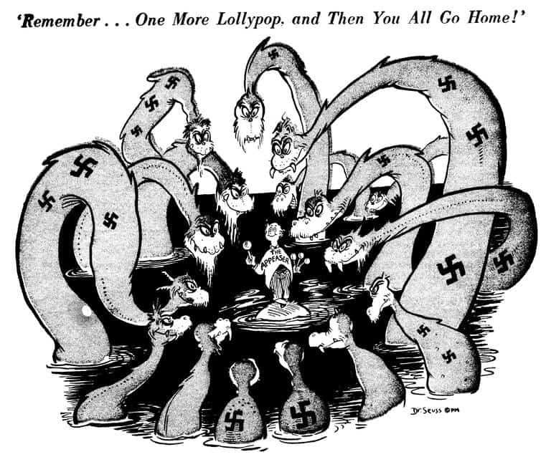
SOURCE 2 Dr Seuss, 1939

